CUSTOMER CHURN PREDICTION
Predicting At-Risk Telecom Customers with Machine Learning
Project Documentation
Advanced Data Analysis Course
Team Members: [Sawsan Sayed , Doaa Mohamed , Mohamed Ihab , SamehAli]
Instructor: [Hagar Hisham]
Submission Date: [18/9/2026]

Table of Contents
Table of Contents 2
1. Executive Summary 4
2. Problem Statement 4
The question 4
Why it matters 4
Scope and boundaries 4
3. Data Sources 5
4. Data Architecture / Data Schema 5
Field groups 5
Data dictionary 5
5. Data Cleaning & Preparation 6
Before / after snapshot 7
6. Exploratory & Statistical Analysis 7
Descriptive statistics 7
Key patterns 7
What these patterns suggested 8
7. Technique Application — Modeling 8
Track chosen: Predictive / Classification 8
Feature preparation 8
Models tried and final choice 9
Final model evaluation (held-out test set) 9
Streamlit app showcase 9
8. Dashboard & Inferred Insights 10
Dashboard structure 10
Key insights 10
9. Conclusion 10
Answer to the original question 10
Limitations 10
Recommendations / next steps 11
10. Appendices 11
Links 11
Data source citation 11
Supplementary materials 11

1. Executive Summary
Business question: Can we identify, in advance, which telecom customers are likely to churn — so the retention team can intervene before they leave?
Key finding: Churn is concentrated among customers on month-to-month contracts, paying by electronic check, with shorter tenure and higher monthly charges; churn rate also varies meaningfully by city (~24%–31%).
Recommended action: Deploy the trained classification model (delivered as a live Streamlit app) to score customers in real time, and route customers flagged as high-risk to the retention team for proactive outreach — for example, a targeted offer before a month-to-month contract renews.
Final model performance on the held-out test set: [insert Accuracy / Precision / Recall / F1 / ROC-AUC from your notebook's Step 8 output].

2. Problem Statement

The question
Telecom providers lose a significant share of their subscriber base every year — in this dataset, 26.5% of customers have churned. By the time a customer formally cancels, the opportunity to retain them has already passed. This project asks: can we predict, ahead of time, which customers are at high risk of churning, using information the company already has on file?

Why it matters
- Acquiring a new customer typically costs 5–25× more than retaining an existing one, so even a modest reduction in churn has a direct impact on revenue.
- The retention team benefits directly: a ranked list of at-risk customers lets them prioritize outreach (discounts, service fixes, check-ins) instead of treating every customer the same.
- Company leadership benefits from visibility into why customers leave — the contract types, payment methods, and service gaps most associated with churn — which can inform product and pricing decisions beyond just the model itself.

Scope and boundaries
- The dataset is a single snapshot of 7,042 customers — it does not track how a given customer's risk changes over time (no repeated observations per customer).
- The analysis covers residential telecom customers across 13 cities (after data cleaning — see Section 5) in the source data; the model's conclusions should not be assumed to generalize to markets or customer segments outside this dataset without validation.
- The project focuses on the classification task itself (will a customer churn) rather than downstream financial modeling of exact retention-campaign ROI.

3. Data Sources
Field | Detail
Dataset name | Telco Customer Churn (extended with a city field)
Origin / link | https://www.kaggle.com/code/basmalaawad/telco-customer-churn-dataset/notebook
Access date | 13/9/2026
Size | 7,042 customer records × 23 columns (after cleaning)
Granularity | One row per customer — a snapshot, not a time series
Licensing / usage notes | [insert license terms shown on the source page, e.g. Kaggle dataset license]

4. Data Architecture / Data Schema
The dataset is a single flat table — one row fully describes one customer at one point in time. There are no separate linked tables to join, so no ER diagram is required; the structure below groups the 23 columns by what they describe.

Field groups
- Customer profile: gender, senior_citizen, partner, dependents, city
- Subscribed services: phone_service, multiple_lines, internet_service, online_security, online_backup, device_protection, tech_support, streaming_tv, streaming_movies
- Account & billing: contract, paperless_billing, payment_method, tenure, tenure_group, monthly_charges, total_charges
- Target: churn

Data dictionary
Field | Type | Meaning
customer_id | string | Unique customer identifier
city | categorical | Customer's city (13 categories after cleaning)
gender | categorical | Male / Female
senior_citizen | categorical | Whether the customer is a senior citizen (Yes/No)
partner | categorical | Whether the customer has a partner
dependents | categorical | Whether the customer has dependents
tenure | numeric | Months the customer has stayed with the company
phone_service | categorical | Whether the customer has phone service
multiple_lines | categorical | Yes / No / No phone service
internet_service | categorical | DSL / Fiber optic / No
online_security | categorical | Yes / No / No internet service
online_backup | categorical | Yes / No / No internet service
device_protection | categorical | Yes / No / No internet service
tech_support | categorical | Yes / No / No internet service
streaming_tv | categorical | Yes / No / No internet service
streaming_movies | categorical | Yes / No / No internet service
contract | categorical | Month-to-month / One year / Two year
paperless_billing | categorical | Yes / No
payment_method | categorical | Electronic check / Mailed check / Bank transfer / Credit card
monthly_charges | numeric | Current monthly charge amount
total_charges | numeric | Total amount charged to the customer to date
tenure_group | categorical | Tenure bucketed into ranges (derived from tenure)
churn | categorical (target) | Whether the customer churned — Yes / No

5. Data Cleaning & Preparation
The table below documents every data-quality issue identified, how it was diagnosed, and the exact fix applied — full code for each step is in the accompanying notebook.
Issue | Diagnosis | Fix applied
TotalCharges stored as text with blank values | 11 rows had a blank string instead of a number (new customers with tenure = 0, not yet billed) | Converted the column to numeric; resolved the blanks so every row has a valid numeric value
Duplicate customer records | Checked for exact duplicate rows and duplicate customer_id values | 0 duplicates found — no rows removed on this basis
Inconsistent city spelling | The same city appeared under two different spellings: "Faiyum" (414 rows) and "Faiyoum" (216 rows) | Standardized both to a single spelling ("Faiyum"), reducing the city category count from 14 to 13 and restoring the true churn-rate signal for that city
Non-predictive / redundant columns | customer_id is a unique identifier; tenure_group duplicates the information already in tenure | Dropped both before modeling (kept in the dataset for reference/dashboard use, excluded from the feature set)
Outlier check | Checked tenure, monthly_charges, and total_charges using the IQR method | No meaningful outliers found — all values fall within expected business ranges

Before / after snapshot
Metric | Before cleaning | After cleaning
Missing values (TotalCharges) | 11 blank rows | 0
Duplicate rows | 0 | 0
Unique city categories | 14 (with a spelling duplicate) | 13
Feature columns used for modeling | 23 raw columns | 21 (customer_id and tenure_group dropped)
Churn class balance | 26.5% Yes / 73.5% No | Unchanged (imbalance handled at modeling time via SMOTE, not by altering the raw data)

6. Exploratory & Statistical Analysis

Descriptive statistics
- 7,042 customers; overall churn rate 26.5% (imbalanced target).
- Tenure, monthly_charges, and total_charges show no significant outliers by the IQR method; monthly_charges and total_charges are right-skewed, consistent with a mix of low-usage and high-usage customers.

Key patterns
- Contract type: month-to-month customers churn at a markedly higher rate than one- or two-year contract holders — the single strongest categorical driver observed.
- Payment method: customers paying by electronic check show the highest churn rate of the four payment methods.
- Tenure and monthly charges: churned customers tend to have shorter tenure and higher monthly charges than retained customers.
- City: churn rate ranges from about 24% (lowest) to about 31% (highest) across the 13 standardized cities — a real, if moderate, geographic effect.

What these patterns suggested
Every pattern above describes a binary outcome (did this customer churn or not) that needs to be predicted from a mix of numeric and categorical features with no natural table joins, no time-ordering to exploit, and no free-text fields to mine. That combination points directly at a supervised binary classification approach — the Predictive/Classification track — rather than Regression (no continuous target), Forecasting (no repeated time-series per customer), Segmentation (there is already a labeled outcome to predict, not an unlabeled grouping problem), or Text/Sentiment (no text fields in the data).

churn | No | Yes | Churn Rate in City
city
Alexandria | 1307 | 454 | 25.78%
Cairo | 989 | 377 | 27.6%
Giza | 444 | 162 | 26.73%
Banha | 321 | 111 | 25.69%
Tanta | 308 | 109 | 26.14%
Faiyum | 314 | 100 | 24.15%
Damietta | 235 | 95 | 28.79%
Mansoura | 235 | 89 | 27.47%
Zagazig | 244 | 86 | 26.06%
Sharm El Sheikh | 219 | 69 | 23.96%
Faiyoum | 149 | 67 | 31.02%
Suez | 159 | 57 | 26.39%
El Mahalla El Kubra | 143 | 55 | 27.78%
Port Said | 106 | 38 | 26.39%
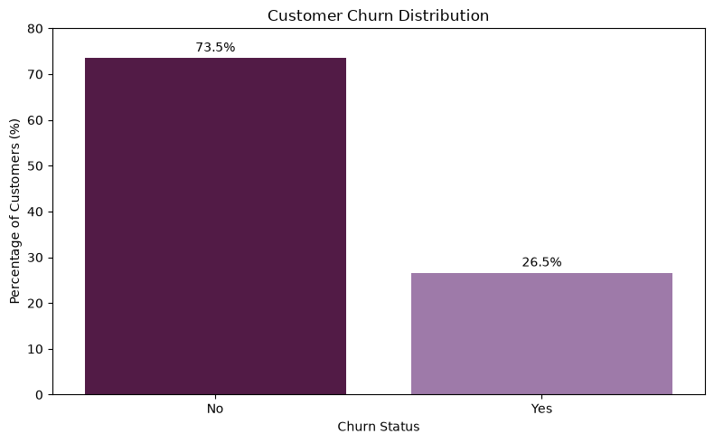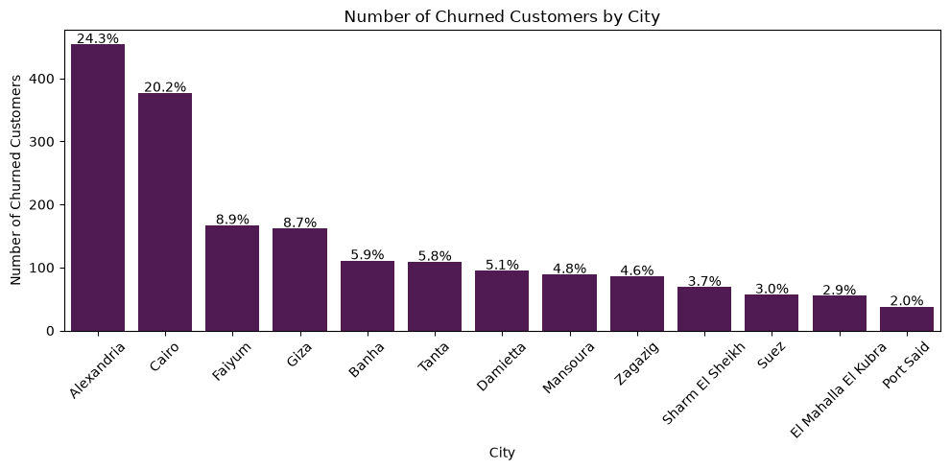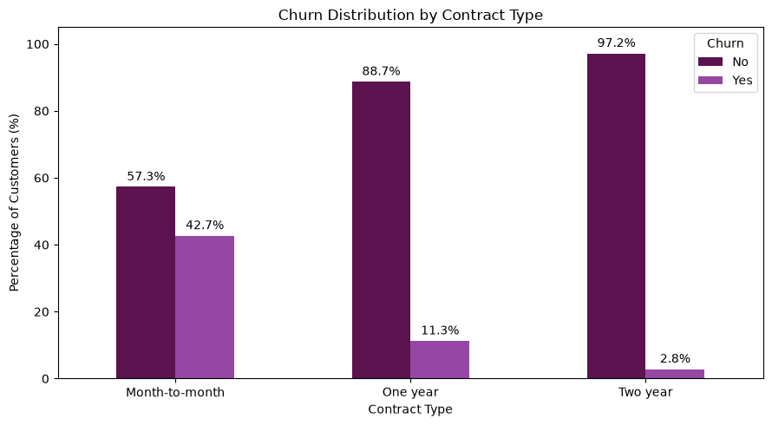

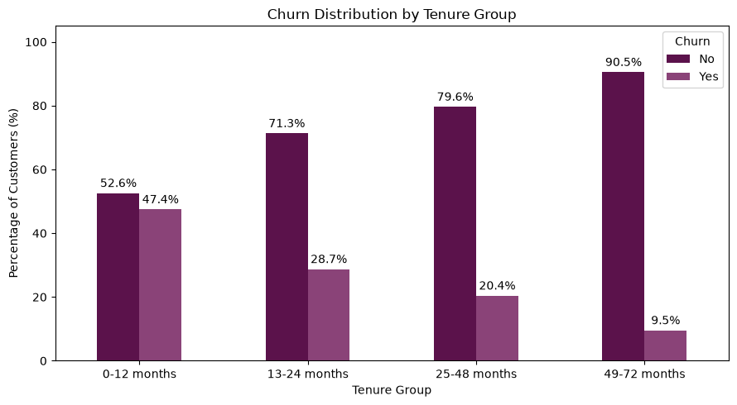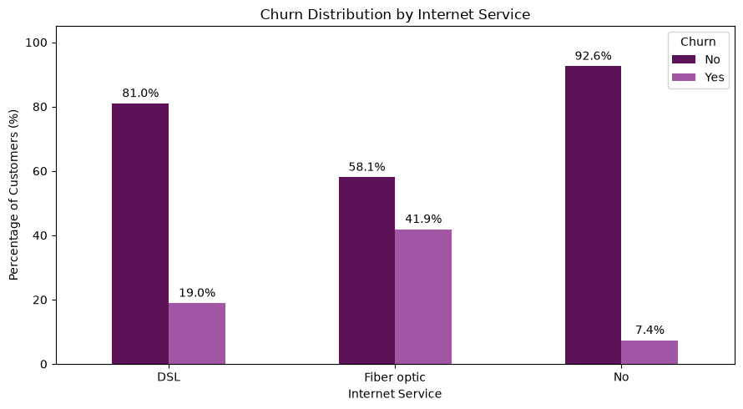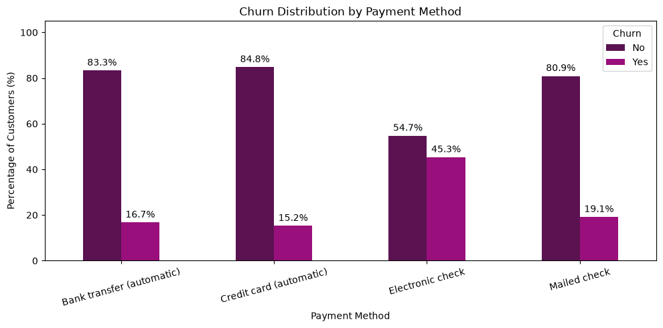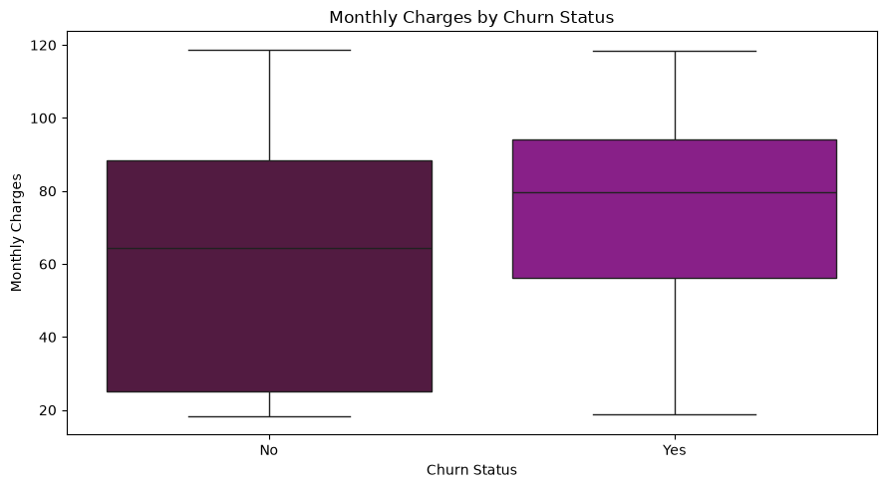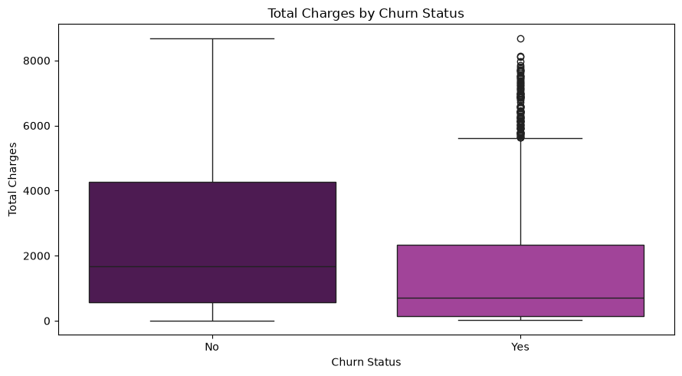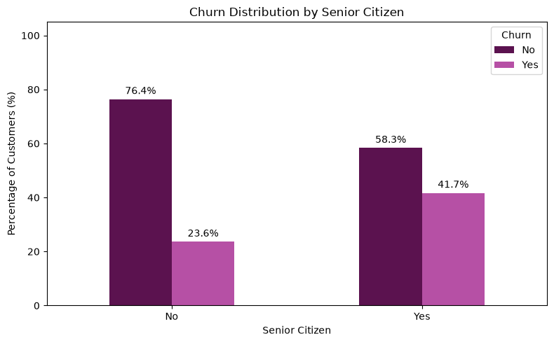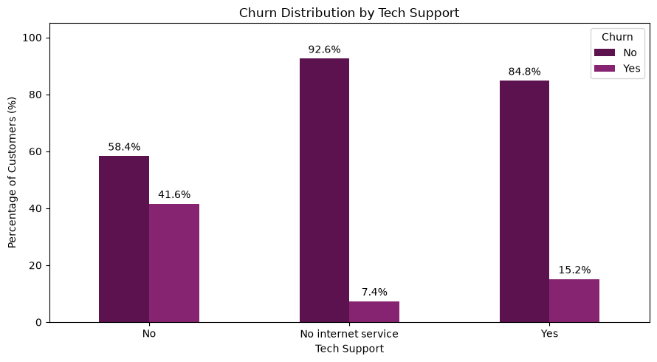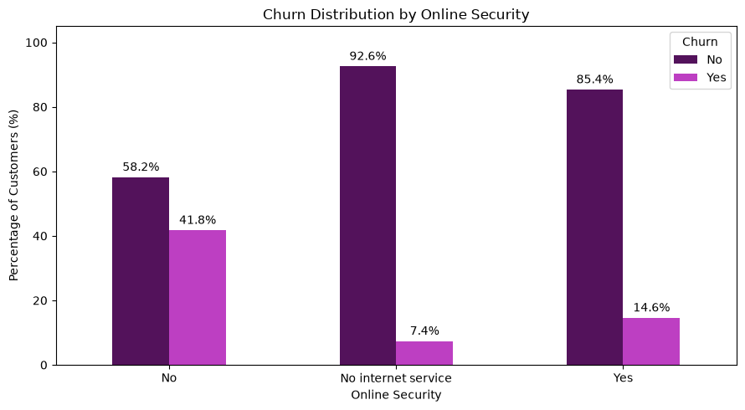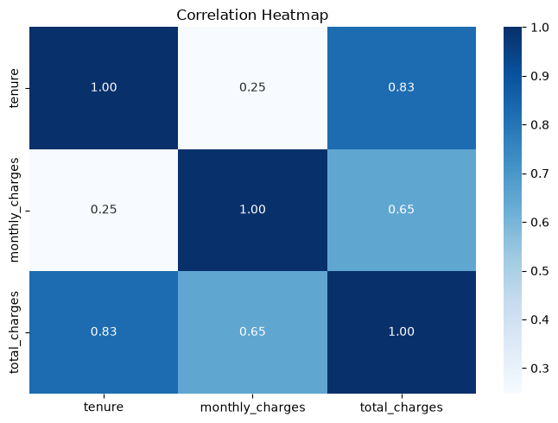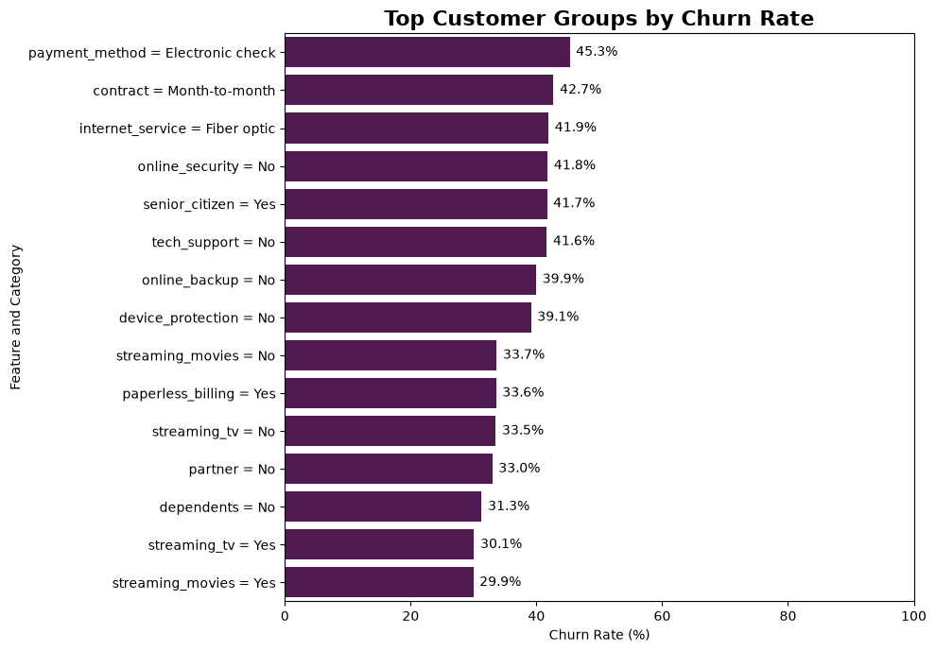7. Technique Application — Modeling

Track chosen: Predictive / Classification
The target variable (churn) is binary (Yes/No), decided per-customer from a mix of demographic, service, and billing features — the textbook case for supervised classification. This fits the question better than the other tracks available: Regression requires a continuous target (churn is categorical); Forecasting requires repeated time-ordered observations per customer (this dataset is a single snapshot); Segmentation would group customers without using the known churn label, discarding the most useful information available; and Text/Sentiment does not apply, as there are no free-text fields.

Feature preparation
- Dropped customer_id (identifier, no predictive value) and tenure_group (redundant with tenure).
- Standardized the city field (merged the "Faiyum"/"Faiyoum" spelling duplicate) before encoding, so it contributes one clean signal instead of two diluted ones.
- Numeric features (tenure, monthly_charges, total_charges) scaled with StandardScaler; categorical features (including city, contract, payment_method, and the service columns) encoded with One-Hot Encoding — both fit on the training set only, inside a scikit-learn ColumnTransformer, to avoid data leakage.
- Class imbalance (26.5% churn) handled with SMOTE inside the modeling pipeline, applied only to the training folds during cross-validation — never to the test set.

Models tried and final choice
Five candidate models were compared using 5-fold Stratified Cross-Validation (to preserve the churn/no-churn ratio in every fold): Logistic Regression, Random Forest, Gradient Boosting, SVC, and K-Nearest Neighbors. The model with the best cross-validated F1-score was selected and then tuned with GridSearchCV.
Model | F1 (CV) | Precision (CV) | Recall (CV) | ROC-AUC (CV)
Logistic Regression | 0.612 | 0.505 | 0.775 | 0.845
Random Forest | 0.633 | 0.526 | 0.794 | 0.846
Gradient Boosting | 0.692 | 0.522 | 0.719 | 0.843
Decision Tree | 0.601 | 0.476 | 0.845 | 0.830

[

Final model evaluation (Logistic Regression)
Metric | Value
Accuracy | 0.739
Precision | 0.505
Recall | 0.775
F1-score | 0.612
ROC-AUC | 0.845

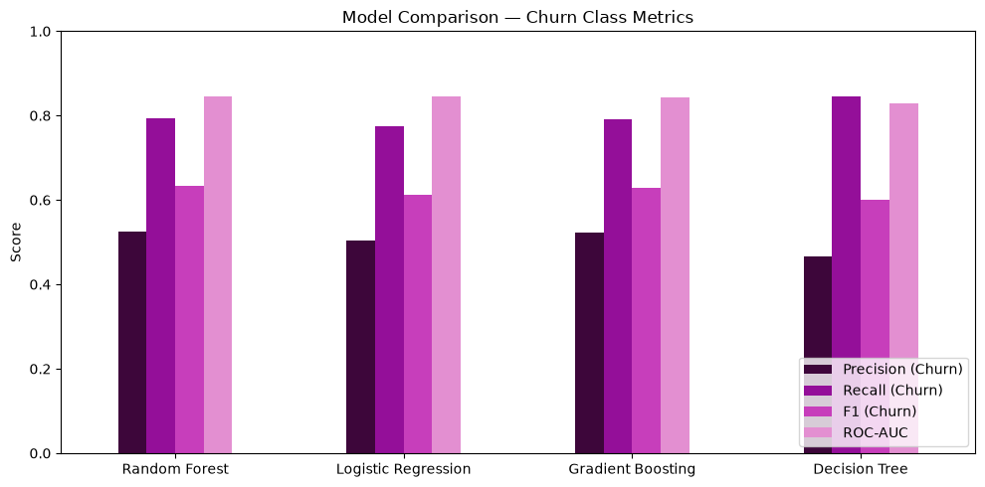

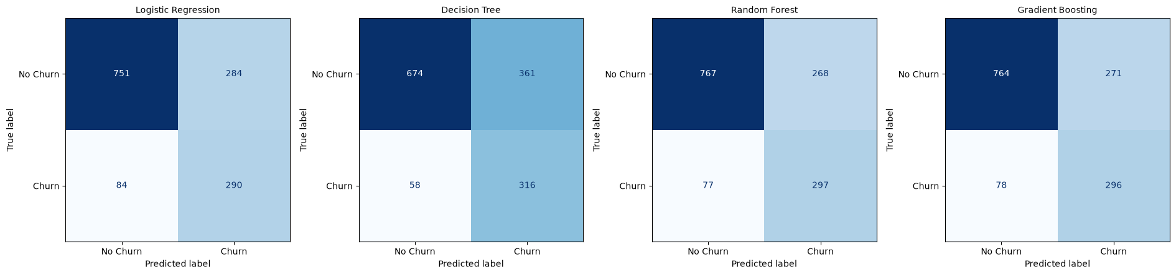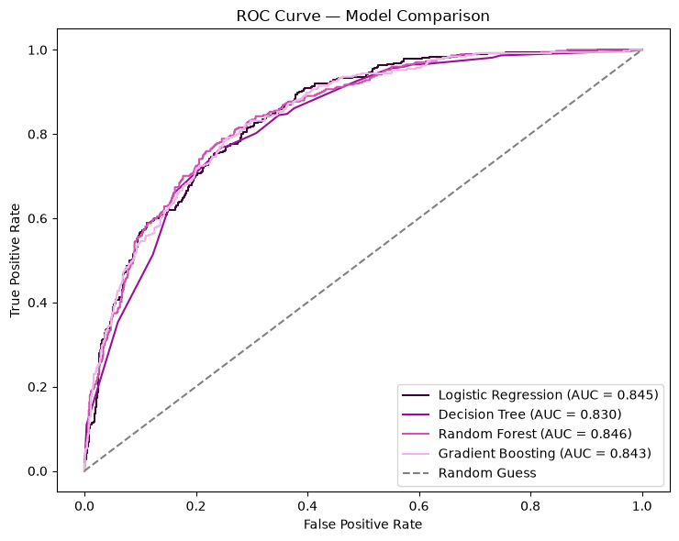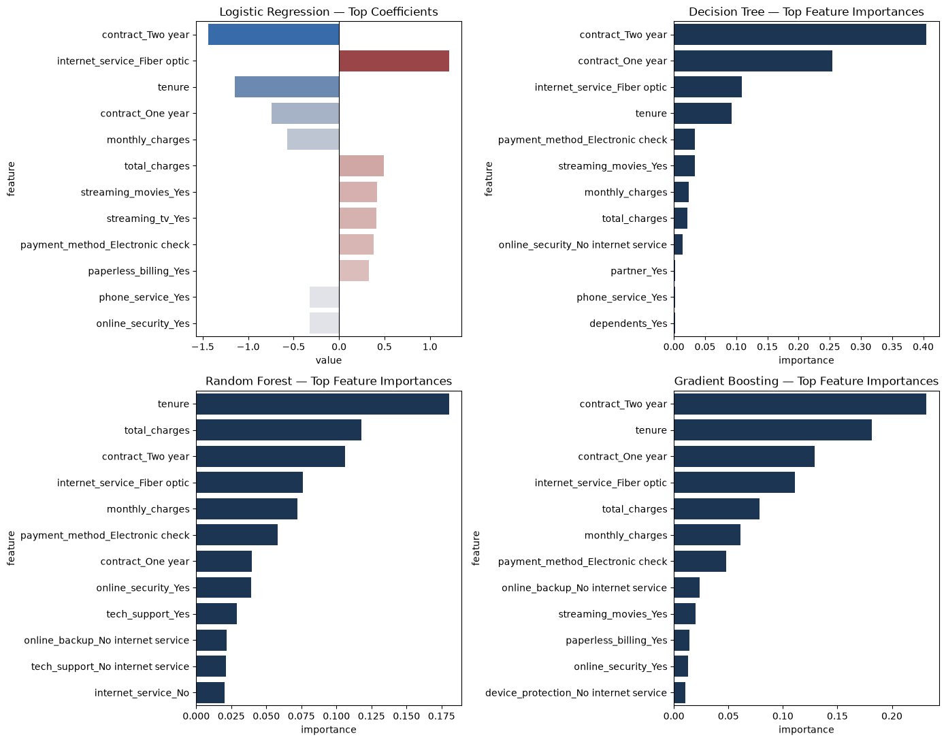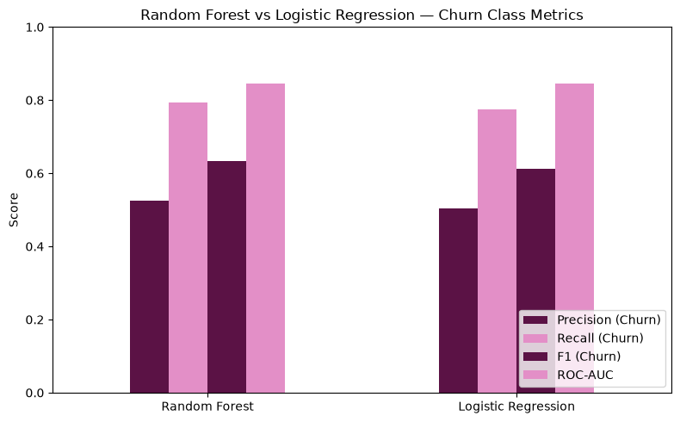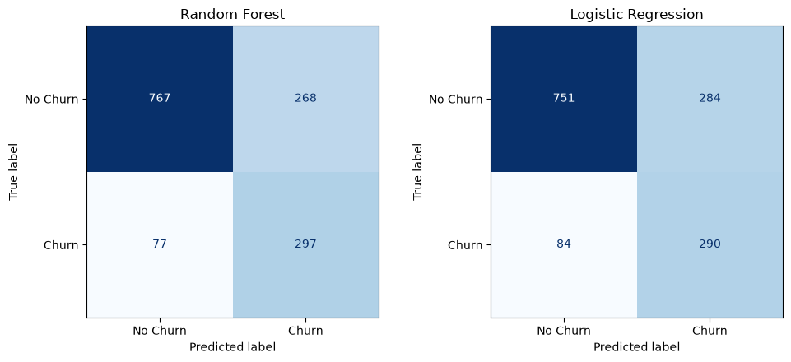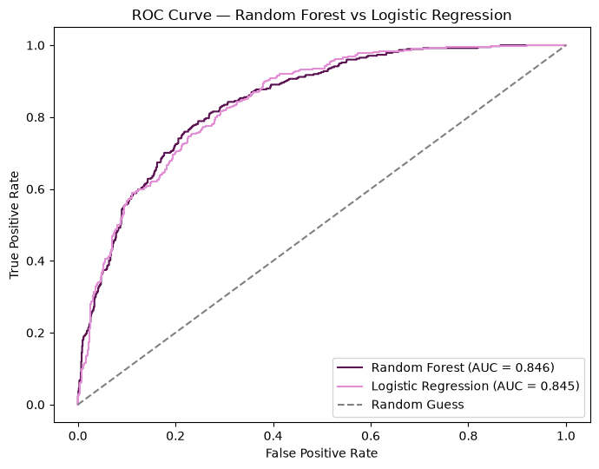Streamlit app showcase
The final tuned pipeline was saved and wrapped in a Streamlit web app, so the trained model can be used without opening the notebook. A retention-team member enters a customer's account and service details (including the new city field) and receives an instant churn-risk score, with a clear high-risk / low-risk verdict.
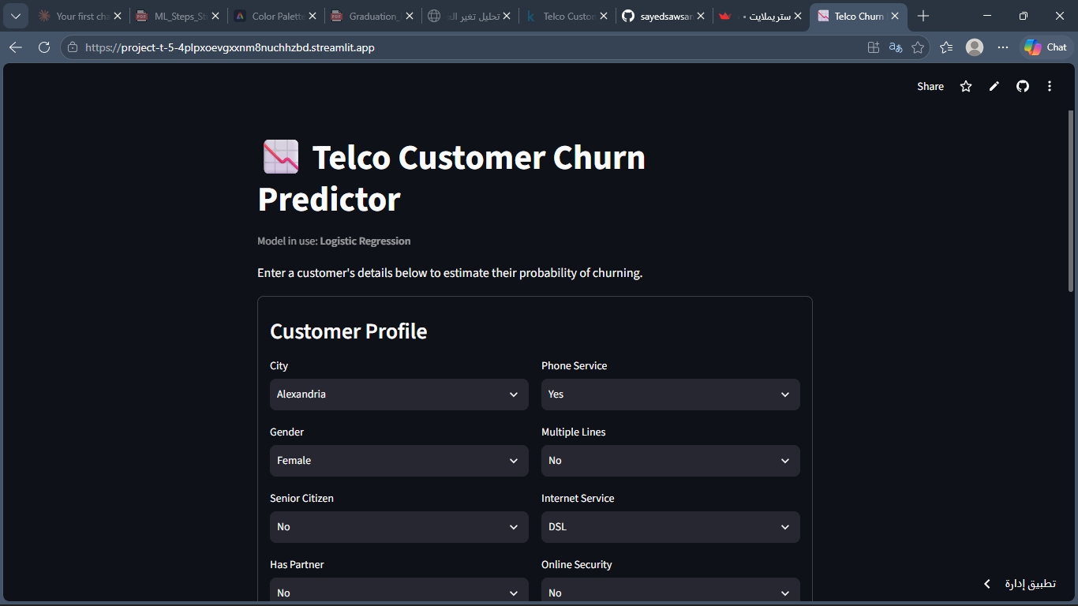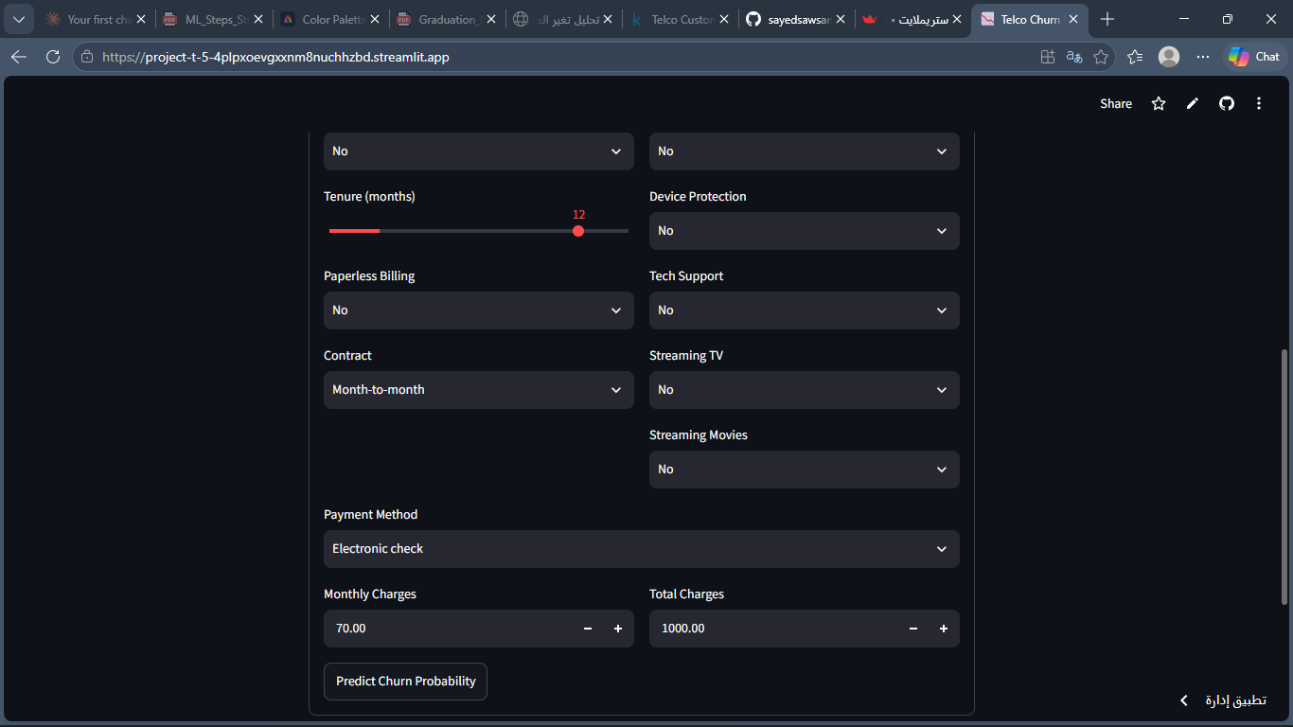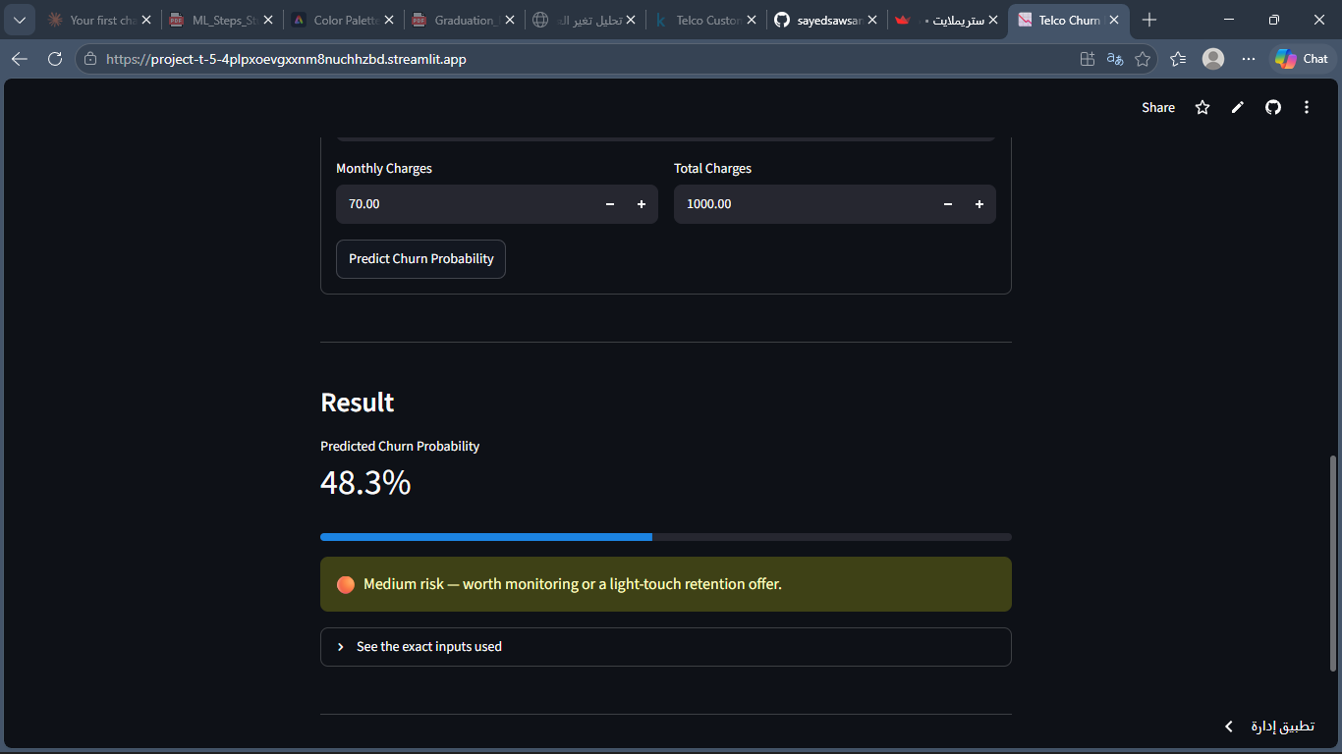

8. Dashboard & Inferred Insights

Dashboard structure
Page | What it answers
1. Overview | What is our overall churn rate, and how much revenue is at risk?
2. Demographics | Which customer segments (gender, age, household) churn more?
3. Services & Contract | How do contract type and payment method relate to churn?
4. Financial / Model Results | What do billing patterns and the model's risk scores tell us, and which features matter most?

Key insights
- Month-to-month contracts churn far more than one- or two-year contracts — the clearest actionable lever available (incentivize longer commitments).
- Customers paying by electronic check show the highest churn risk of any payment method.
- Shorter tenure and higher monthly charges both raise churn risk — newer, higher-paying customers need the most attention.
- Churn rate varies by city (~24%–31%) — worth a closer look at whether service quality or local competition differs by region.
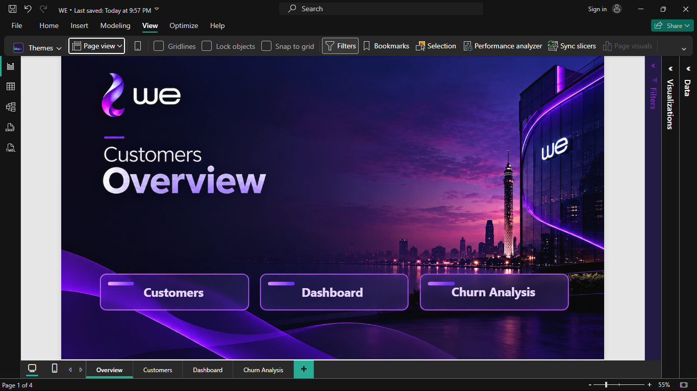

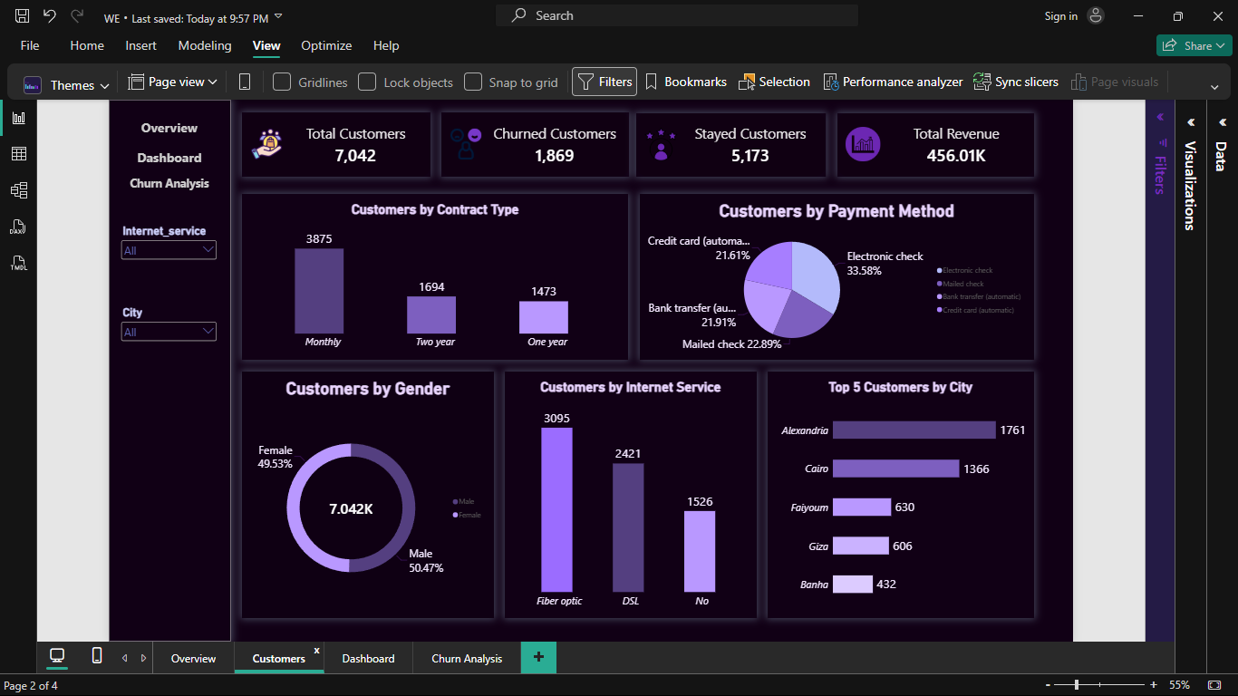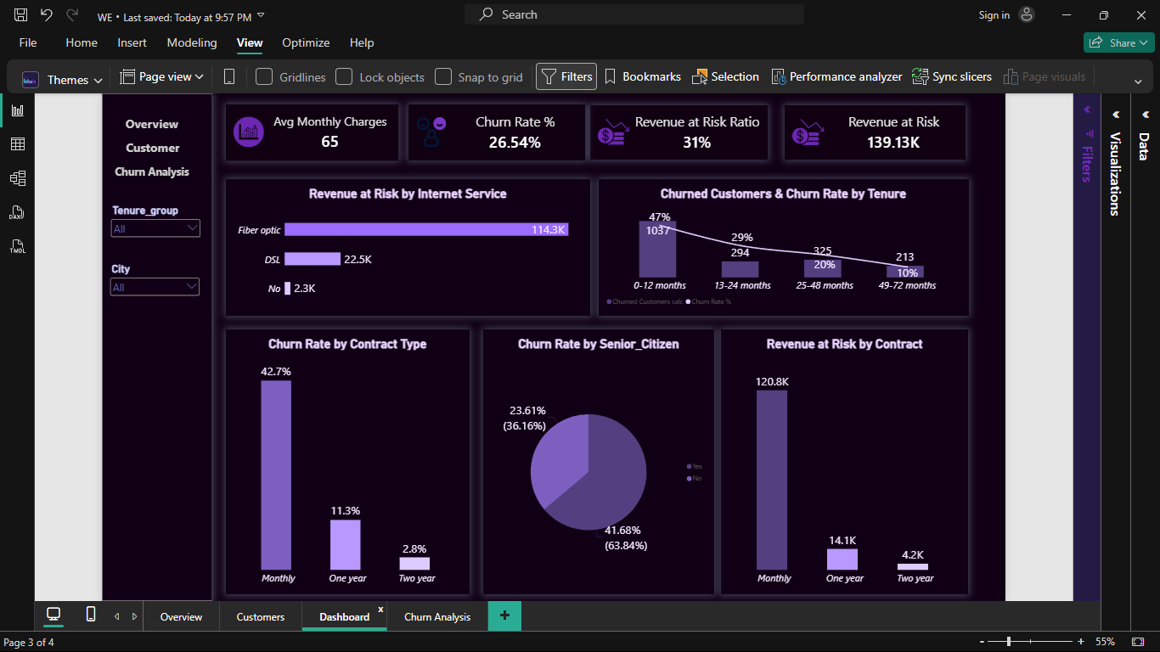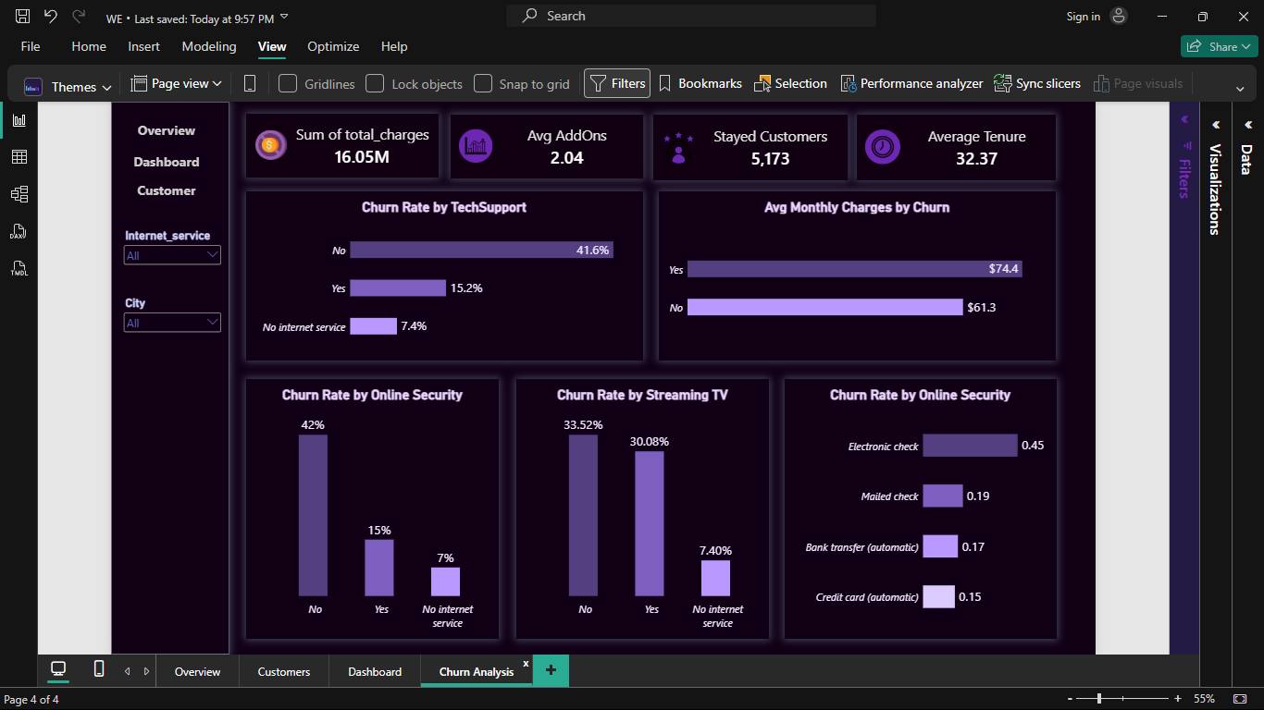

9. Conclusion

Answer to the original question
Yes — churn can be predicted meaningfully ahead of time using the account, service, and billing data the company already holds. The trained model gives the retention team a ranked, actionable list of at-risk customers instead of waiting to observe cancellations after the fact.

Limitations
- The dataset is a single snapshot with no time dimension, so the model cannot yet detect a customer's risk changing month to month.
- The model's precision/recall trade-off ([insert your actual final numbers]) means some false positives (flagging a customer who would not have churned) and false negatives (missing a customer who does churn) are expected — retention outreach should be sized accordingly.
- Findings reflect this specific customer base and set of cities; applying the model elsewhere would need re-validation.

Recommendations / next steps
- Deploy the Streamlit app (or integrate the saved pipeline directly) so the retention team can score customers routinely, not just once.
- Prioritize retention offers for month-to-month, electronic-check customers in their first year — the segment with the clearest combined risk factors.
- Investigate the higher-churn cities directly (service quality, competitor presence) rather than relying on the model alone.
- Revisit the model periodically as new data accumulates, and consider adding a time dimension (e.g. monthly snapshots) to catch rising risk earlier.

10. Appendices

Links
- GitHub repository: [ https://github.com/sayedsawsan70-wq/Project-T-5#project-t-5 ]
- Streamlit app: [ https://project-t-5-4plpxoevgxxnm8nuchhzbd.streamlit.app ]

Data source citation
Telco Customer Churn dataset. Source :
[https://www.kaggle.com/code/basmalaawad/telco-customer-churn-dataset/notebook ].

